Answer Test :

Test Case **Q1.**

**Q2.**

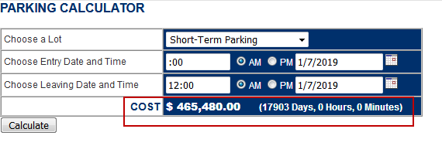

- Bug Description : Calculate cost wrong if field “Entry Time” empty

Test Step :

1. Set selectbox “Choose a lot” to be “Short-Term Parking”
2. Input field Entry time “00”
3. Set Date entry “1/7/2019”
4. Input field Leaving Time “12:00”
5. Set Date leaving “1/7/2019”
6. Click button “Calculate:
7. Verify the results

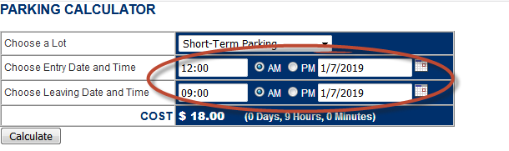

- Bug Description : Leaving time can set less than Entry time, no validation for that caseSet selectbox 1. Set selectbox “Choose a lot” to be “Short-Term Parking”

1. Input field Entry time “12:00”
2. Set Date entry “1/7/2019”
3. Input field Leaving Time “09:00”
4. Set Date leaving “1/7/2019”
5. Click button “Calculate”
6. Verify the results

**Q3.**

- How many data entries are available for the category - Animals ? ***12 Data***

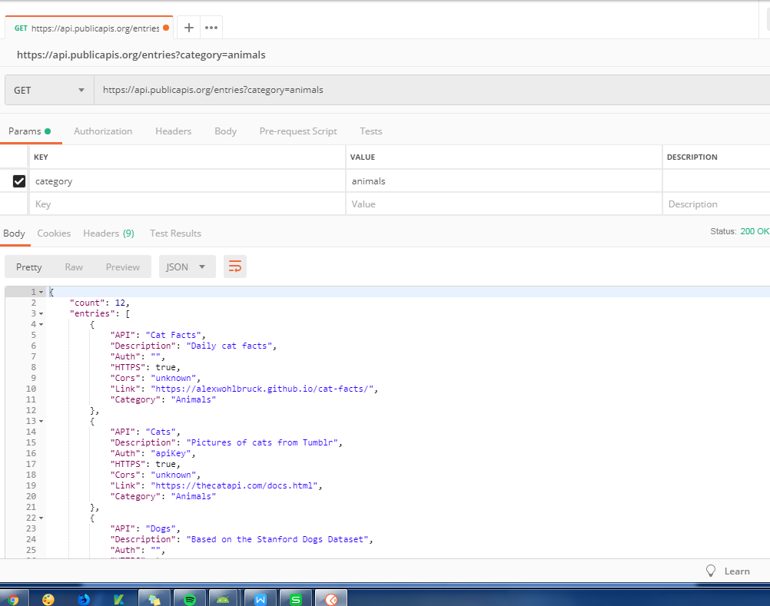

- Return the link/URL of any website related to holidays ? ***1 data with link “https://holidayapi.com”***

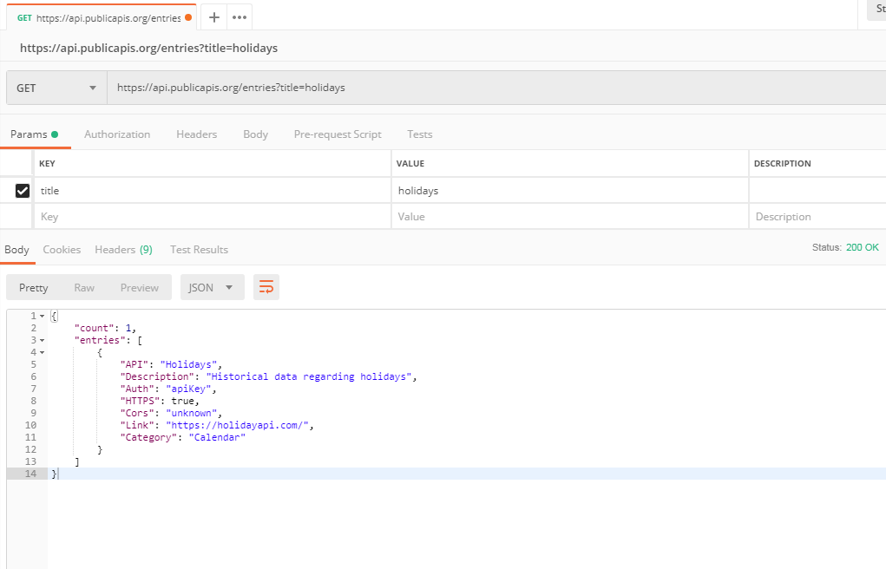

**Q4. Answer script automation with RobotFramework**

**Enter all required fields (cover only positive cases) and register your account**

*** Settings ***  
Library *SeleniumLibrary*\*\*\* Variables ***  
${Browser} *Chrome*${URL} *https://www.cermati.com/gabung*${delay} *7s*\*\*\* Keywords ***  
Register New Account  
 Input Text *name=email zulkifliabdulah@gmail.com* Input Text *name=password zulkifli12* sleep ${delay}  
 Input Text *name=firstName Zul Kifli* Input Text *name=lastName Abdulah* Input Text *name=mobilePhone 081281232590* Input Text *name=residenceCity KOTA JAKARTA SELATAN* click Element *xpath://*[@id="body"]/div/div[1]/div/div/div/form/button*\*\*\* Test Cases ***  
Login Web Bizzy  
 Open Browser ${URL} ${Browser}  
 Maximize Browser window  
 Register New Account